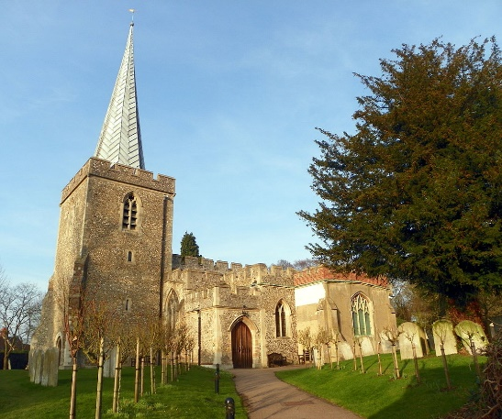 | St Nicholas Church, Stevenage (SG1 4DA, National Grid Reference: TL 24074 26207) is Grade 1 listed (since 1948). It forms a group with ‘Moonhill’ and ‘Dominic Cottage’; adjacent buildings on the south side, that are both Grade II listed. St Nicholas’ Church is located in the St Nicholas/Rectory Lane Conservation Area, which was first designated in July 1982. The boundary was amended in 1984. A St Nicholas/Rectory Lane Conservation Area Management Plan Supplementary Planning Document was adopted in July 2012.
An independent, detailed review of the heritage of St Nicholas, was commissioned (O’Callaghan and Coulter, Artemis Heritage Partnership, March 2018¹) to help assess the significance of the building. A copy is available on the church website.
The church is in a beautiful location, surrounded by a glorious wooded graveyard (now closed) with footpaths leading through the graveyard to open countryside beyond.
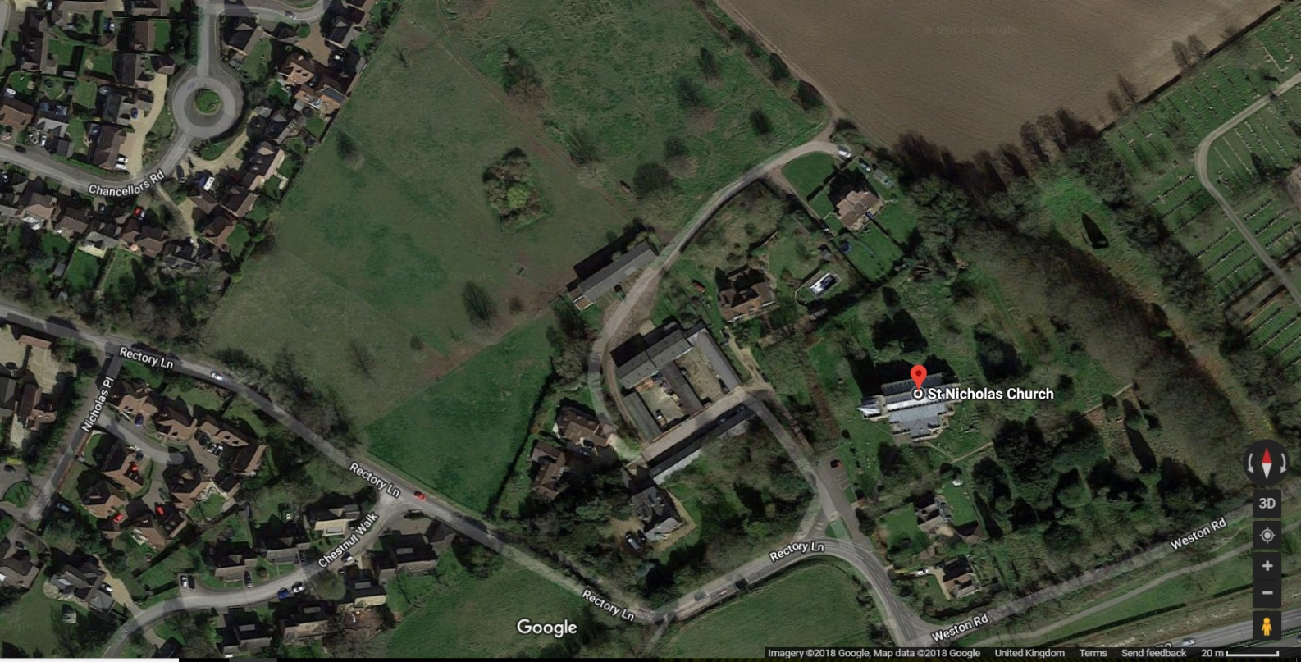
It is thought that a Saxon church was built on the hilltop site around 1066, next to the Manor House, this was replaced by a 12th Century Norman church around 1100 A.D. The only remaining part of the Norman church is the thick-walled 52ft Romanesque flint tower which supports a lead-covered spire, which rises a further 50 feet into the air; the spire was added around 1500.

Over the centuries the church has changed greatly as each generation has left its mark on the building, adapting and developing it to serve the purposes of worshiping God and preaching the Gospel in their own day.

In the 13th Century the church consisted of an aisled nave and chancel. There may have been a chapel on the south side of the chancel, but not on the north.

In the third quarter of the 14th Century the church underwent a substantial rebuilding programme. This included the wooden tower stairs and the building of the chapels flanking the chancel and the sanctuary. This work probably included the first set of screens comprising the main chancel screen, the western parclose screens and the screen now in the Stevenage Museum.

The choir stalls with misericord seats probably date to the 14th century, though it is not certain whether they were created for the church or imported into St Nicholas at the Dissolution of the Monasteries in the 16th century.

In the middle of the 15th Century the church underwent a scheme of very extensive modifications. This included; the arches of the nave arcade, the clerestory, the insertion of large windows (e.g. those immediately west of the screens), the roof, font cover, and the second set of screens (the present south chapel screen and two eastern parclose screens) and the tracery preserved in the choir desk frontals.

In the 16th Century the choir stalls were modified (Green Man misericord, and top rail added) and the tracery now forming part of the priest’s chair was carved. This may have been carried out following the acquisition of the stalls in an imperfect state following the Dissolution.
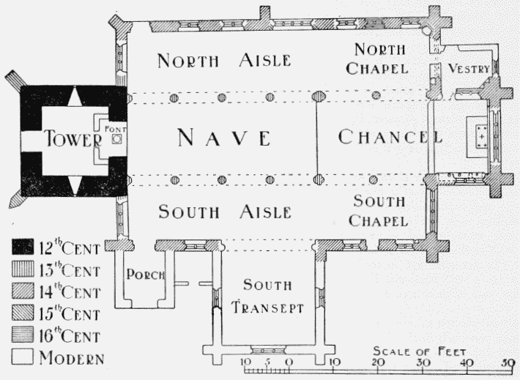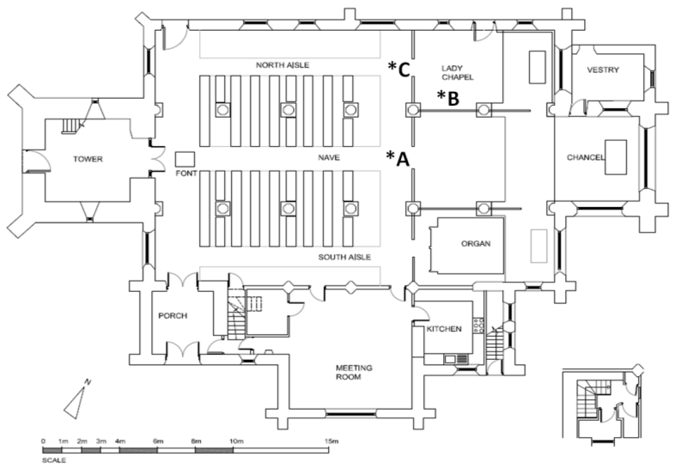
Layout in 1912² Layout in 2017

The building was extensively re-developed in the 19th Century (1841-2), again in the early 20th Century (1913-15) and to a lesser extent in 1960-65 and 1977, with other changes occurring as necessary in between. A detailed timeline of 19th and 20th century changes is shown in the table at the end of this statement.

In the early part of the 21st Century the church was redecorated and some items of furniture, such as the pulpit and choir pews, removed to provide a more flexible space in front of the wooden screens. The organ was re-sited into what was formerly the Trinity Chapel, enabling a larger kitchen and an accessible toilet to be built. Shortly after this a new sound system was installed.

However, the most substantial changes took place between 2019-2020 when a major reordering and refurbishment project was undertaken. This included a new stone floor, with underfloor heating beneath, a new lighting scheme, and the re-siting of 3 wooden screens to create a larger worship space and a crèche in the north-western corner. To increase the amount of accommodation for small group use, such as our Sunday children’s work, the mezzanine floor was fitted over the existing parish room. The bricked-up arches between the chancel and the parish room were removed and replaced with glass screens at the top level and glass doors on the ground floor. The whole church was then redecorated and six electronic display screens installed. The result has been to create a large, light and flexible worship and meeting space, which still retains its historic feel. The changes have been very well received.

Despite these many changes, the church remains full of history and historical artefacts. These include the bowl of the ancient font (13th C), the grave slab of one of the early rectors (early 14th C), which lies in the centre of the church and the six carved misericord choir stalls, dating from the late 14th/early 15th century, now positioned at the west end of the north aisle. One particular highlight is the collection of mediaeval graffiti carved onto a number of pillars around the church. Unsurprisingly, the refurbishment project and replacement of the floor revealed many interesting archaeological discoveries and the full report⁶ has been lodged with Stevenage Museum and Hertfordshire Archive and Local Studies, it is also is available on the church’s website.

Other notable parts of the church include one of the oldest staircases in Hertfordshire in the tower (dendro-dated to the late 14th century), some beautiful examples of 19th and 20th century stained glass windows and a recently renovated and restored Forster and Andrews organ, built in 1884. The reredos designed by Sir Charles Nicholson and installed in 1915 is appreciated by many members of the church. Nicholson also designed an altar frontal which is still in regular use. The end chapel is flanked by a small vestry on the north side and on the south side by a double Piscina and 3 Sedilia re-discovered and restored in 1841.

A full Record of the Church Furnishings was created by the National Association of Decorative and Fine Arts Societies³ in 2009 and in February 2013 Dr Charles Tracy FSA reviewed the age and likely provenance of the wooden screens, and choir stalls with misericords. None of the ancient wooden screens were removed from the building during the 2019-20 refurbishment.

The main body of the church still has 3 aisles and is fitted with Robert Thompson oak pews dating from 1964. The new layout formed a small chapel at the east end of the church using a screen that dates to the 14th or 15th century. This particular screen was removed from the church at some point in its history, possibly during the Reformation, before being re-discovered in a tithe barn circa1840. Since that time, it has been in a number of positions.

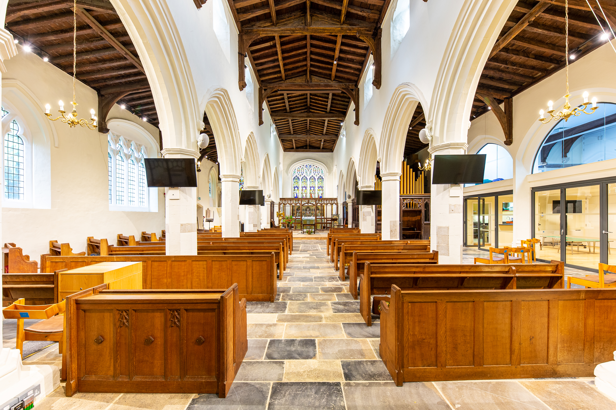
Interior of St Nicholas Church in December 2020

Assessment of Significance.
Using guidance suggested by Historic England, O’Callaghan and Coulter (Artemis Heritage Partnership, March 2018 ¹) have systematically evaluated the significance of the heritage within St Nicholas church:

St Nicholas is a Grade 1 listed building.
Taken as a whole this is recognition that the heritage of St Nicholas church building is of national significance.

The medieval building
The church is substantially a medieval building, with fabric dating from the twelfth to the fifteenth centuries. All of this is of high significance.

The wooden screens
The surviving medieval screens at the entrance to the chancel, the Trinity chapel and parclose screens between the chancel and the two flanking chapels are important survivors from the 14th and 15th century and thus of high significance. There is ample evidence, both documentary and physical, that they have all been moved at different periods and modified to varying degrees. This is part of their history and does not diminish their significance.

Other furniture and fittings
The church possesses a number of significant medieval furniture and fittings, sometimes incorporated into later features. All of these are of either high or moderate-high significance (see main text of reference 1 for detail). The choir stalls can be associated with the church at least as far back as the sixteenth century. Nicholson’s desks incorporate material that is contemporary with some of the parclose screens, and a Victorian chair incorporates late medieval carving that can be linked to one of the misericords.

Monuments and floor
The church has a modest collection of monuments of varying significance. Few if any seem to be in their original location as we know that the floor has been re-laid and most of the floor slabs align with the, now removed, nineteenth-century pew platforms. None of these were moved during the 2019-20 refurbishment.

Nineteenth-century restorations
Although there were substantial interventions in the fabric of the building in the nineteenth century, little, of any heritage significance survives, beyond some stained-glass windows and the stump of the south transept.

Nicholson’s restoration
Nicholson’s early twentieth-century restoration of the church had a major impact on the spaces within the building. Anson (1960) describes him as “… the really representative Anglican architect of the present century. He designed furnishings that were both traditional and refined.” “A typical Charles Nicholson interior reflects the spirit of the Caroline Divines. Both Archbishop Laud and Bishop Andrews would feel quite at home in them.” At Stevenage he created a new south aisle, incorporating the Victorian transept and replacing the south aisle wall with a new arcade. He restored the chancel screen and returned it to its presumed original location. However, budgetary constraints and the outbreak of war meant that his scheme was not fully implemented. Following the 2019-2020 refurbishment, the influence of Nicholson is still to be seen throughout the building, ranging from the altar frontal and reredos to the extended south transept and boiler house!

Conclusion
St Nicholas has undergone a lot of change since the Norman church was built nearly 1000 years ago. It has a long history of change; each generation has kept it in good repair and developed the building to meet the needs of the worshiping community, radical redevelopments have often occurred at intervals of 75 to 100yrs. As a consequence, the building is a rich heritage of artefacts ranging from the 12th century tower, 14th and 15th century screens and stairs through to the 20th century reredos and pews. The history of St Nicholas church building is one of adaptation and development over many centuries, to meet the needs of Christians worshiping God in Stevenage.

Revd. David Brown, Mr Mike Wilton and Mrs Karen Walker
Rector and Churchwardens, St Nicholas Church, Stevenage
References:
- “St Nicholas Church, Stevenage. Assessment of Heritage Significance”
Brian O’Callaghan PhD and Diana Coulter MA, Artemis Heritage Partnership, March 2018
- “'Parishes: Stevenage', A History of the County of Hertford:”
Volume 3, ed. William Page VCH (London, 1912), pp. 139-148.
British History Online http://www.british-history.ac.uk/vch/herts/vol3/pp139-148 [accessed 25 September 2017].
- “Record of Church Furnishings, St Nicholas, Stevenage, Hertfordshire.” 2009
The National Association of Decorative and Fine Arts
- “St Nicholas, Stevenage, Hertfordshire. A significance assessment of the historic timber furnishings.”
1st February 2013. Charles Tracy B.A. Ph.D. FSA
- “The Restorations of the Parish Church (St. Nicholas) Stevenage.” Author un-known April 1933
- “Archaeological Observation and Recording Report, St Nicholas Church Rectory Lane Stevenage Hertfordshire”
Karin Kaye MA MCIfA, Carina Summerfield-Hill MSc ACIfA & Laura Dodd MSc ACIfA, KDK Archaeology Ltd, September 2020

Timeline of changes in the 19th, 20th and 21st Centuries:
Constructed using the NADFAS, an article written in 1933⁵ and a description in the Victoria Country History² published in 1912. The VCH includes a plan of the church, which predates extensive changes initiated in 1913.

Version 1
Date: January 2021
Date | Description
1824 | Stone effigy: found upside down being used as a step in S Aisle
1836 | Barrel and finger organ installed on Quire gallery at W end of the Nave
1841 | Oak panelling, plaster and brick removed from chancel/sanctuary, revealing windows on N & S side; a door on the N side and Piscina & Sedilia on South.
 | Floor of Chancel (up to Communion precincts) lowered nearly 1 foot.
 | Piscina (alcoves in Sanctuary) plaster stripped and restored
 | Sedilia (alcove seats in Sanctuary) plaster stripped and restored
 | Old and dilapidated Communion rails replaced with Gothic ones, which were in turn replaced in 1939.
 | Parclose screens: Trinity chapel. Mid/late 15C. In 1841 the old screens lowered two feet to 'the present and apparently original position'.
 | Parclose screens: Lady Chapel, Mid/late 15C. Installation 1841 by analogy with Parclose screens around Trinity chapel.
 | Chancel screen: 15C Canon Bloomfield (1834-74) discovered the screen in a tithe barn about 1840. He carefully pieced it together and placed it as a reredos.
 | Old pews removed, new ones erected on uniform plan
 | South Transept built
 | Baptistery altered; font relocated to beneath the Western arch of the Nave.
 | Plain Grecian east window removed, replaced by Tudor Gothic one
1842 | Stained glass put in to east window
1871 | Quire gallery at W end of Nave demolished, organ moved to N Chancel
1884 | New Forster & Andrews organ installed facing N in the most eastern bay of the North/Trinity chapel
Date | Description
1913 | Church is damp, especially N Aisle. Wood floors under pews are rotten.
 | Extension to South transept built, including boiler house.
1914 | Chancel Floor lowered
 | Deal pews removed, chairs provided
 | New Floor, wooden blocks on concrete
 | New Heating Apparatus in boiler house
 | Chancel screen (*A) placed in its current position. After restoration the screen was put back in its original position as a memorial to Revd Bloomfield. Part of it is in Stevenage Museum
 | Tower arch opened
 | Three blocked windows opened
 | Oak Doors in place of deal.
1915 | Reredos designed by Sir Charles Nicholson installed
 | Organ moved into S transept extension.
1939 | Current altar rails, replaced 1841 Gothic ones.
1960 | Formation of a Lady Chapel on the N side of the main chancel, including pews instead of the existing chairs; altar rails, altar cross and candlesticks, statue of the Lady of the Isles in an existing niche in the NE corner.
1961 | Parclose screen: Lady Chapel, west side. 1961 as part of the refurbishment of the Lady Chapel in 1960
1964 | Oak Pews installed in nave, designed and made by Robert Thompson
1979 | Parish room formed by enclosing the arcade between the S aisle and S transept. Including a servery between S transept and S porch. Provision of toilets at 1st floor level
1984 | New heating system
1996-2002 | Main outer doors added, original doors re-located to base of the tower, inner glass doors added to south porch
2002- 2016 | Removal of choir pews, pulpit, reading desk. Relocation of organ, building of new kitchen and accessible ground floor toilet and installation of new sound system. Extensive improvement to the drainage around the external perimeter of the building
2019-2020 | Major renewal and refurbishment project. New stone floor fitted with underfloor heating, new lighting scheme, and the re-siting of 3 wooden screens to create a larger, brighter and more flexible worship space. Crèche in the NW corner. A mezzanine floor was built over the Parish Room with glass screen/doors replacing the in-filled arches. 6 electronic display screens were installed to compliment the recently installed sound system.

January, 2021.

